MINI PROJECT
C PROGRAMMING
Mini Project: Loop Optimization Demo
Project Title: Loop Optimization Demo
Topic Name: Compare Loops
Programming Language: C
Expected Outcome: Iteration Count Comparison

Objective

To compare the working of for loop and while loop by performing the same task and counting the number of iterations executed by each loop.

Problem Description

In this project, a simple counting task is performed using:

a for loop

a while loop

A counter variable is used to count how many times each loop runs.
Finally, the iteration counts are printed to compare both loops.

Approach / Detailed Walkthrough
- Initialize a limit value.
- Use a for loop to run from 1 to the limit.
- Increment a counter for each iteration of the for loop.
- Repeat the same task using a while loop.
- Increment another counter for the while loop.
- Print both iteration counts.
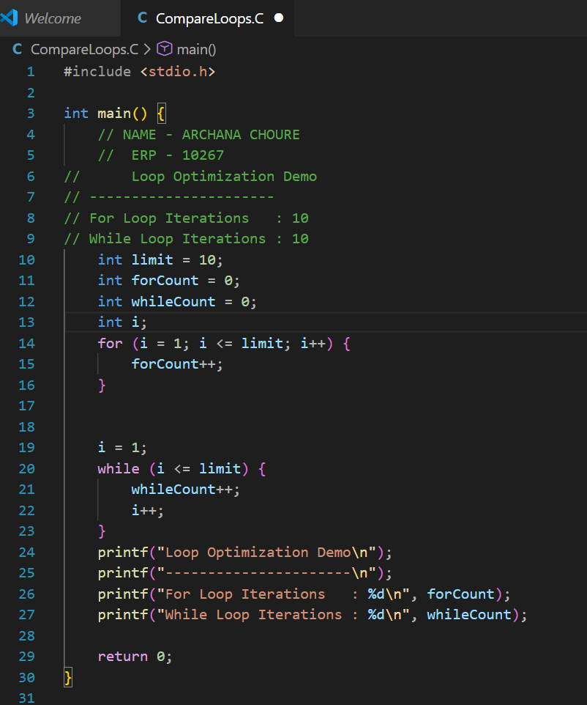

Conclusion
- Both for loop and while loop executed the same number of iterations.
- Iteration count depends on the condition, not the loop type.
- Choice of loop improves readability, not performance, in simple cases.

